High-Level
SMART GOALS!!!!!!!!!!!!!!! are u a smart fella or a fart smella………

- how to market to our specific audience for optimal views -> steam wishlists ratio.
- trailers, gameplay reels, and devlogs
- research part: audience, messaging, platforms
  - how do we capture the attention of a brainfried gen z'er and make them stop doomscrolling and open steam to press Wishlist.
- submittable:
  - week-by-week marketing plan
  - exo's marketing narrative
  - reel ideas in more detail (gameplay clips, devlogs, funnies, subway surfers)

Views -> Wishlists
get game out to as many interested parties as possible

Views
How to maximize views for indie game content

Turnover %
aim for high percentage of wishlists to views (e.g. most ppl who view it should wishlist)

Example of an AVG view -> wishlist ratio:
- 50k views on 1 video -> 500 (1%) steam visits (0.5% -> 2%)
  - Realistic number
  - Likely lower % turnover over time with repeated viewers
  - Likely higher views over time with increased exposure
- 500 steam visits -> 50 (10%) wishlists
  - This seems very low, considering once they’re on the page it’s just clicking one button…
    - But, if they're on mobile, they likely aren’t signed in, and Steam mobile is very difficult :/
  - The polish level of the steam page needs to be as polished as its shown in the video
  - If a video goes viral, put that video as a gif at the top of the steam description
  - Optimize for mobile viewers

Potentially email newsletter. Google form give ur email, “welcome to EXO community, here’s steam to wishlist”

Narrative & Hooks

BOG Identity
- Fiery/Competitive:
  - “We built a movement shooter for people who think ultrakill is too slow. This is REAL speed.”
  - Build friction and debate in the comments -> user engagement
- Educational?
  - “Movement shooters arent actually fast. Games fake speed with massive FOVs and tight spaces. Here’s how they do it:...”
  - “Here is how WE build real speed in EXO”
  - ‘Industry secrets’
    - The fkn loading screen LOL. that would be a really good video, not exo specific, but a good video nonetheless
- Students:
  - “As students…”
  - “We have exactly 4 weeks to make our movement shooter look good enough to get signed by Devolver Digital / Critical Reflex”
  - Underdog edge

Gen Z Audience
- Doom scrollers, Dopamine junkies, Brain fried
- Need it easy, low-friction

Content to make

Game Trailer
- MUST GRAB ATTENTION INSTANTLY
- MUST BRING TO STEAM PAGE
- [0:00-0:05] start IN action. 3 seconds of "YOOOOO", then a crazy psychological hook text: {"these worlds are beyond saving, they need purging", "we built a movement shooter for people who think ultrakill is too slow", "this is REAL speed"}
- [0:05-0:30] fluidity loop. movement. continuous, unedited perfect run (show its real, and not a camera trick)
- [0:30-1:15] depth showcase. weapons, high skill. (show choice and options, quick cuts. 5 seconds of weapons, 5 of level aesthetics, 5 of a boss, 5 of a movement technique)
- [1:15-1:30] call to action. steam link. title card EXO logo, show wishlists/playtest metrics, call to action: "Wishlist on Steam" / "Want to play right now? Click the link to join our Discord / Steam Playtest" (and then require the player to Wishlist and request Steam Playtest Access in order to get a key)

Gameplay short-forms (15-30 seconds)
- edited, super attention-grabbing
- 50 million trending audios
- MUST GRAB ATTENTION INSTANTLY
- MUST BRING TO STEAM PAGE

Dev Talks (much calmer)
- “we are running a hidden 48-hour playtest this weekend. click 'Request Access' on our Steam page to secure your spot”
- Ask audience questions what they want to see
- “As students…” (unique hook)
- Make a bold claim,, and then teach about it via something we learned by developing exo
  - “Movement shooters aren't fast”, “games fake speed”, …

Devlogs
- Make the devs make these lol? YES Would be funny to see how different they are

Funny short-forms?
- subway surfers and minecraft parkour gameplay

Publisher Trailer (basically unedited gameplay)
- 90 second gameplay recording: [0-10] Speed/Action, [10-30] polish, UI clarity, juice [30+] show more

Upload to

Ads
- Instagram ads ← good for spreading the game
  - need to have professional instagram account first, check BOG insta to see if this is #truthnuke
    - Get verified maybe for #officialness

Social Media
- Youtube shorts
- Reels
- Tiktok

Talk to

Creator Outreach
- Creators that just share upcoming games

insta | contact | notes
@randy sulei | randysulei@gmail.com | might be expensive? might be free? who knows
@cloudual | cloud@shared.games
@jestr.gg | contact@jestr.gg

- Other indie game devs
  - E.g., Third Shift Studios
- Indie game content creators

- Lurkit
  - https://www.lurkit.gg/game-studios
  - Costs moneys…

Mentor Outreach
- UCI connections
  - utilize professor connections and advertise dat game
    - “Kurt can u pls quote repost our linkedin post and shout it out in class 🥺”
    - Kurt
    - Roberts
    - Reid
    - Dennenberg
- USC connections
  - Jared (malachy)
    - Can he give us connections to people in the publishing studios to talk with casually?
- VGDC connections
  - Dorothy (malachy & karina)
- GDC connections
  - Meta lady (malachy & gavin)
  - That one indie lady (karina)
- Gage’s connections
  - Mycopunk (conner)

Send to

Conventions
- Gameacon ($206 to be featured on their Steam page + booth + get a QR code to Steam displayed during event, in October at Coachella Valley) (BOG weekend trip?)
- some may require expensive af sponsorship (cough cough looking at u anime impulse)

Showcases
- Summer Games Fest
  - EXO Publisher + Monetary Options (Showcases tab, from Nancy)
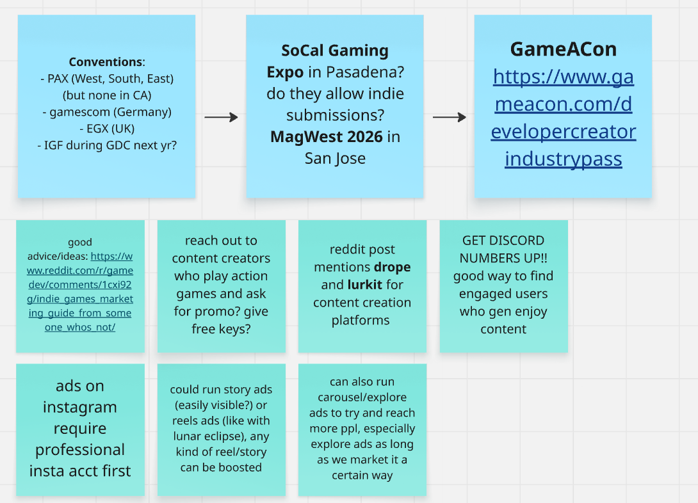

Production

Strategy
https://www.reddit.com/r/gamedev/comments/1cxi92g/indie_games_marketing_guide_from_someone_whos_not/
- know your ultimate goal (steam wishlists)
- optimize steam page with high-quality, distinct art that encapsulates the game as a whole, especially capsule art
- create community hub (done on discord) (all socials and promos should funnel into this one place)
- reach out thru content creator platforms for free promotion (focus on those who love the genre and love showcasing new content
- run contests/giveaways/competitions

Timeline

Weekly Video Posts

Sunday 8:30 PM The Hook

Trends x Dev Log
- Dev log over trending audio
- Meme format but fit to game
- Meme format but fit to development of game (bug struggles)

CTA: Follow Us

Creators:
- Nicole Capcut
- Lyndsey ?

Ideas:
- [varies weekly]

Wednesday 4:00 PM Teach

Educational & how we made this
- Explaining industry concepts/secrets
- Behind-the-scenes building process

CTA: Follow Us (with pinned comment pointing to Steam)

Creators:
- Writing ANY DEV
- Editing Nicole Capcut
- Editing Joey Davinci Resolve?

Ideas:
- About Us (PINNED)
  - Humanize us
  - Developing as Students x About us
  - Include faces and funny stuff like chaotic desk setups
- How games fake speed
- Unreal Engine is easy, actually
- People said this game was impossible

Thursday 7:30 PM The Game

Trailer with a hyper-focussed theme each week
  - Breakdown of a specific mechanic, specific lore, interesting combo

CTA: Wishlist on Steam

Editors:
- Nicole Capcut For verticals
- Joey Davinci Resolve? For horizontals
- Malachy Premiere Pro For horizontals

Ideas:
- 30 second TRAILER (PINNED)
  - Pure visual adrenaline
  - Look like a polished AAA at indie size
- POV Dopamine (PINNED)
  - Grab attention for low attention spans
  - “POV: You’re trying to survive 5 seconds in our indie game”
- We were told our game is impossible
- Before and Afters
  - Movement-Combat System
  - Planets
  - etc.

Video Format
- Start in action ALWAYS
- End with steam link CTA, potentially a cliffhanger too

Who do what
- Lyndsey - idea guy, can script/storyboard for specific ideas
- Nicole - editor guy

Week-by-Week Schedule

Week 12
- Marketing plan

Week 11
- ‼️‼️‼️Ideate - Content
  - Ideate for reels and trailer, then tell dev team what parts to polish hella so it looks amazeballs - nicole, lyndsey, nancy, malachy, joey
  - Ideate reels ideas - lyndsey
- reels/gifs start
  - record footage for reels/gifs - malachy, joey
    - What footage? - marketing
  - edit reels - nicole > joey > malachy
  - Short-form tests?
    - Goal is to see what formula works
- Get ad perms on IG Reels & YouTube Shorts
  - (are we a business account yet for insta? make sure to change it if we’re not) - conner yes –conner
- Steam Page
  - (friday team meeting) - talk about steam page and trailer
  - https://store.steampowered.com/app/4587490/EXO/

Week 10
- GIFs for Steam
- Script the 90 second Game Trailer (or start week 11)

Week 9
- Update Steam with GIFs
- Release 90 second Game Trailer

Week 8
- Open Steam Playtest
  - And post video “we are running a hidden playtest this weekend. Hit Request Access on Steam”
- Ideate content creator outreach

Week 7
- Reach out to content creators with playtest access keys
- Assist Publishing with pitch deck, if needed

Week 6
- Stylize pitch materials. (contents will already be made)
- (this is the last week of Steam Playtests)

Weeks 5-4
- TBD
- continue with making and posting content

Content
Stuff we can make content about:
- How the game started
- Who the team is
- The Speed genre
- Inspirations
  - Space spaceship, hailmary, lunar eclipse?
  - Planet exploration
  - Cool art and vfx
  - ARTREMIS
- Development Challenges
- We are students
- August 12 eclipse
- WOW full moon tonight!!!
  - Marketing aligned with space events?!

Content

Steam GIFs
- Player going very fast around planet or in front of sun
- Movement Core Loop
- High APM Action Sequence (chained weapons/abilities)
- Challenge (e.g., big boss, much danger, next planet)

Game Reels
- <15 second gameplay
  - Invisible loop
- 5 second teasers (for reach) - 3 second gameplay, 2 second CTA
  - 1 second SUPERLOOP of us LOOPING planet
    - “Hypnosis”
    - 
    - “hold side of screen to make him run 2x faster” and then make the video like 2 seconds long so it’ll loop over and over and we’ll get straight numbers

Dev Vlogs
- 30-45 seconds

CTA?
- 15 seconds
- Ways to do this
  - Analyze a cool clip from a user, then tell them to try and do better
  - Informative of “what is playtesting and why is it important?”
  - Super vibey “shhh… steam playtest time. secure your spot.”
    - ^^ be part of the next most awesome upcoming indie game
      - Be sure to show that we are implementing feedback in future posts
  - ‼️Implement suggestion. “Last time, players said this, this user had x idea, so we implemented it and its awesome”
  - “Join the discord to see your feedback/ideas in the game” “be part of the playtest” (smth like that)

TRAILER
- 90 seconds
- [0:00-0:05] start IN action. 3 seconds of "YOOOOO", then a crazy psychological hook text: {"these worlds are beyond saving, they need purging", "we built a movement shooter for people who tink ultrakill is too slow", "this is REAL speed"}
- [0:05-0:30] fluidity loop. movement. continuous, unedited perfect run (show its real, and not a camera trick)
- [0:30-1:15] depth showcase. weapons, high skill (show choice and options, quick cuts. 5 seconds of weapons, 5 of level aesthetics, 5 of a boss, 5 of a movement technique)
- [1:15-1:30] call to action. steam link. title card EXO logo, show wishlists/playtest metrics, call to action: "Wishlist on Steam" / "Want to play right now? Click the link to join our Discord / Steam Playtest" (and then require the player to Wishlist and request Steam Playtest Access in order to get a key)

Goals (Measurable)

How to Make as Easy-to-Accomplish as Possible
- Our genre is really good for short form content, so we can be ambitious here
- Make rule that devs MUST record footage when implementing a new feature or fixing a bug, and then put this in the GDrive
- Consistent reels schedule
  - Consistent roles:
    - Lyndsey - Ideation
    - Nicole - lead editing
      - Joey and Malachy - supplemental editing
- Dev focus is for publishing/marketing, so we’ll be focussing on what looks good in small playtime/segments

Goals by Week 5

Views: 5-10k per, 50k+ on one
- 5-10k view baseline per video
- with a 50k+ view breakout video
- Done by
- <5 second videos
- invisible loops
- high action starts
- loud hooks

Steam: 10-15% conversion
- 10-15% steam page conversion
- Needs
  - Fire GIFs
  - Fire 90 Second trailer
- Done by
  - Optimize for mobile

Wishlists: 5000+
- 5k+ wishlists
- Done by
  - Friday Playtest
  - Constant plugging

Submission Materials

Indiecade
- Artistic Statement
In approximately 100-300 words, describe your intentions creating this piece.
Explain why you created it and why it matters to you and people in general. Tell us the goal for your piece, how you want it to work, or how you want people to feel. We are looking for themes, motivations, and points of view.
Express some of the important creative ideas behind your game that we are not able to see from simply looking at it. You can also talk about your practice as a gamemaker and how this connects to your submission.
- Artistic Statement (100-300 words)*

EXO was born from a unified frustration shared by our team of game design students, all of whom bonded over competitive, high-octane and fast titles like Valorant, Ultrakill, and Haste. In our discussions, we realized a fundamental paradox in modern game design: most "movement shooters" aren't actually fast. Instead, they rely on tight camera angles, motion blur, and high actions-per-minute (APM) inputs to simulate a feeling of speed while keeping actual velocity remarkably low.

Our goal was to shatter this convention. We challenged ourselves to smash the third-person shooter and extreme physics-based platformer genres together to see what breaks, and more importantly, how to make it fun. EXO treats velocity not as a visual effect, but as the player’s primary weapon. We designed the experience to minimize downtime and maximize continuous kinetic action. By doing so, we aim to deliver a novel sense of power and a pure, undeniable sense of "aura" as players effortlessly break planetary orbit.

As emerging gamemakers, this project represents our philosophy: games should push boundaries rather than rely on established comfort zones. We want players to feel the visceral thrill of true, unrestricted momentum, forcing them to rethink what high-speed traversal actually means in a combat environment.

- 200/300
- Statement of Innovation
In approximately 100-300 words, describe how you feel that your submission is unique and pushing beyond the edge of how we currently think about play and games.
Use this space to highlight content, technical, theoretical, and other innovations in your piece. Describe how these elements support the themes, motivations, etc. provided in your artistic statement.
- Statement of Innovation (100-300 words)*
EXO achieves what enthusiasts and developers from both the third-person shooter and extreme-speed racing communities routinely claim is impossible: seamlessly melding pinpoint combat precision with unthrottled, mach-speed velocity. Traditionally, these genres are fundamentally incompatible. High-speed traversal destroys a player's ability to aim, while the stop-and-start nature of precision shooting instantly kills a player's momentum. To fuse them, we could not just tweak existing design tropes—we had to completely rebuild locomotion and target acquisition mechanics from the ground up.

Our primary technical breakthrough is a custom spaceship-style locomotion system mapped onto a third-person, spherical planetary environment. By utilizing a spherical world, players literally witness their compounding speed as the planet's horizon bends beneath them. To resolve the mental strain of separating WASD movement from high-velocity camera tracking, our engine treats the player character as a central location indicator. This locks the camera into a pseudo-first-person axis while maintaining a third-person field of view, blending steering and aiming into a single fluid input.

Furthermore, we threw out traditional hitscan and aim-assist frameworks, which are useless at our velocities. Instead, we engineered a localized "kinetic explosion zone" around enemies, rewarding high-speed drive-by passes rather than static pixel tracking. Combined with an aggressive, arced enemy AI that naturally flows with the player’s orbital trajectory rather than forcing momentum-killing U-turns, EXO shatters the perceived boundaries of play. We have proven that speed and shooting are not mutually exclusive—they are explosive catalysts for each other.

- 239/300

Trailer

